Setting Up the TIMS Dashboard

Dashboard Overview
TIMS Dashboards are customized to display specific views of TSDS incident information. Pre-designed dashboards are accessible to TIMS users at each level of TSDS support. Incoming tickets for each support level are displayed in the upper right section of the dashboard, titled Lx Support Queue.
Support Level | Dashboard Name
Level 1 – LEA Data Steward | L1 Support Queue
Level 2 – ESC Support | L2 Support Queue
Level 3 – TEA TSDS Support | L3 Support Queue
Level 4 – TSDS Component Owner | L4 Support Queue

Setting Up Dashboards
TIMS support users set the dashboard appropriate for their support level as follows:
- From the Dashboards menu select Manage Dashboards.
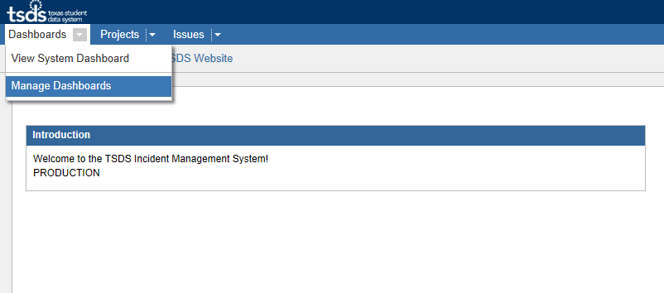

- Select the Search tab on the left-hand side of the page.
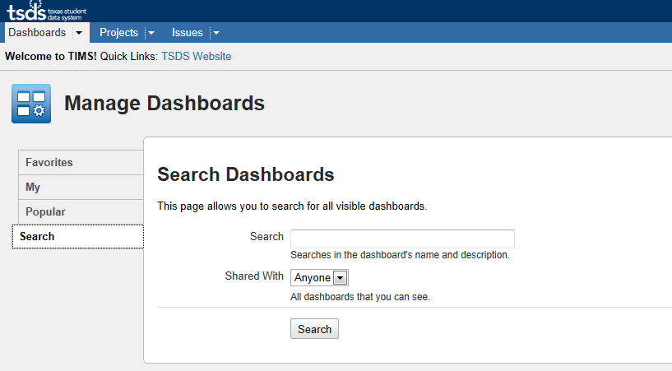
Note: To view all available dashboards, leave the Search field blank.

- Click Search.
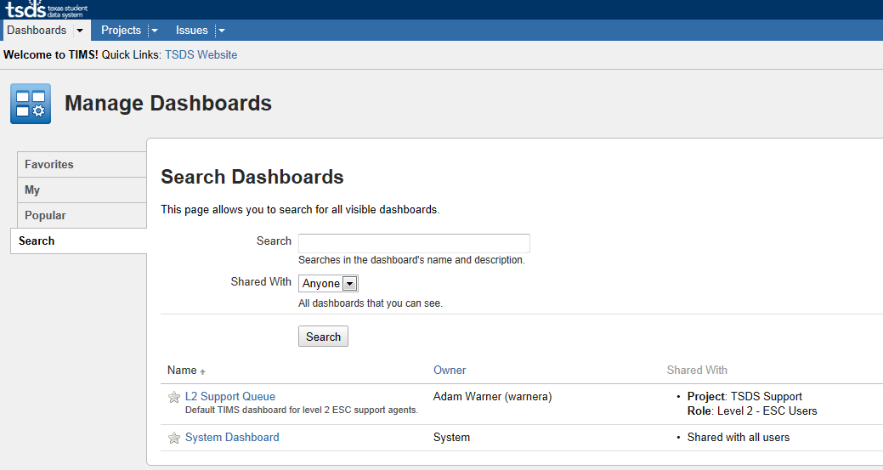

- Select the dashboard that corresponds to your support role level. (Example: ESC would select L2 Support Queue; LEA would select L1 Support Queue, etc.)
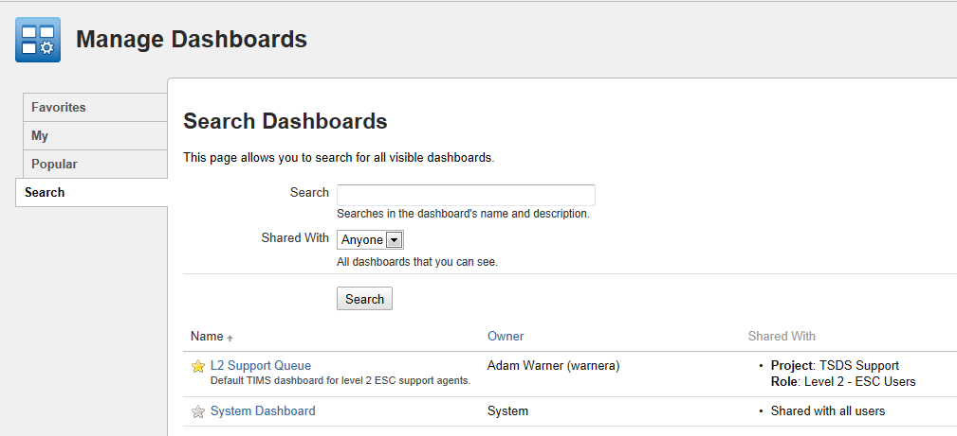
Note: The dashboard you are viewing will only be displayed temporarily, until you add it as a favorite.

- To add the Dashboard as a favorite click the “add it as a favorite” link.
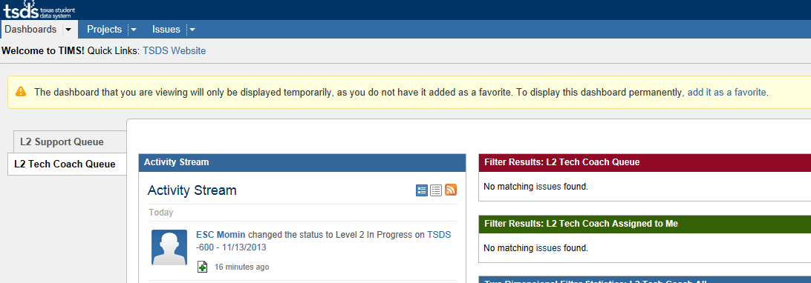
- Select Dashboards on the navigation menu to choose a favorite dashboard view.
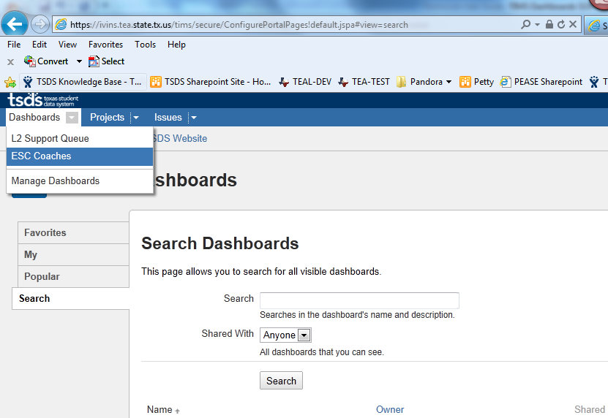
The dashboard will load the gadgets from the pre-designed dashboard view selected.
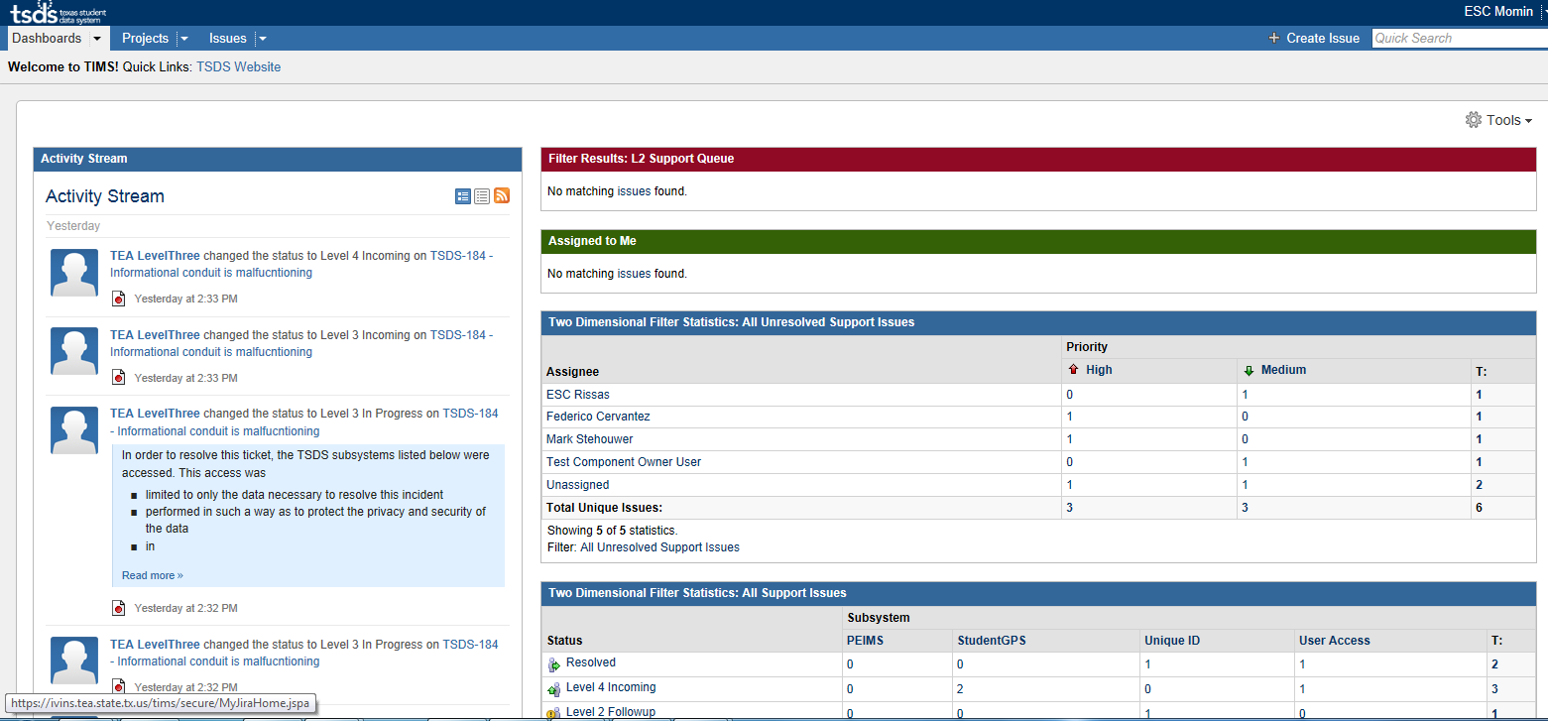
Your TIMS dashboard view is complete.

